M-Pesa API Test Results For Mlexbeautyspa

|  |  |
| --- | --- |
| End Point / Scenario | Results |
| Session Id Requisition | Passed |
| Request processed successfully | Passed |
| Request timeout | Passed |
| USSD Push timeout | Failed |
| Transaction Failed [Incorrect PIN] | Passed |
| Internal Error | Passed |
| Transaction Failed [Incorrect PIN] | Passed |
| Invalid Amount Used | Passed |
| Insufficient balance | Passed |
| Service is not available | Failed |

See response details below

**Session ID Request 01**

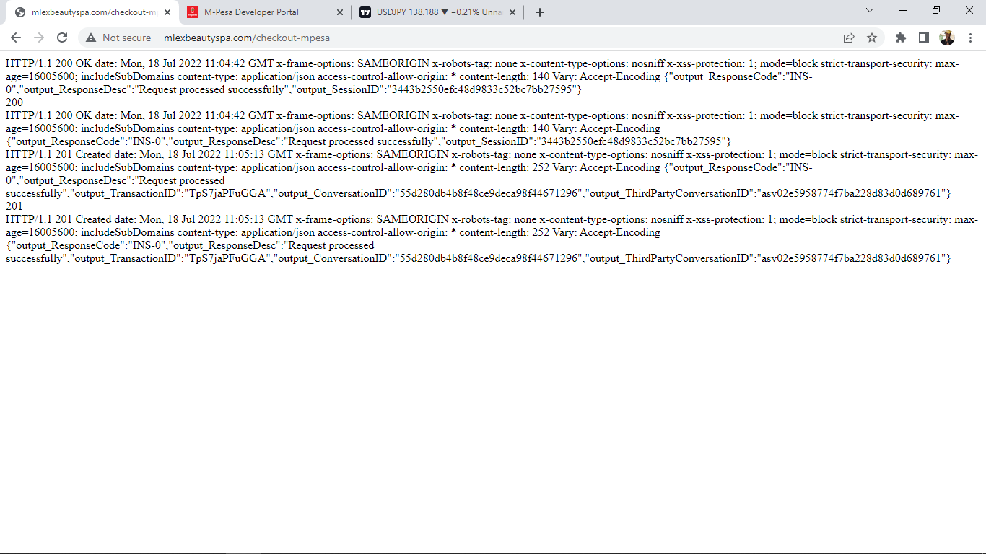

**Request Timeout 02**

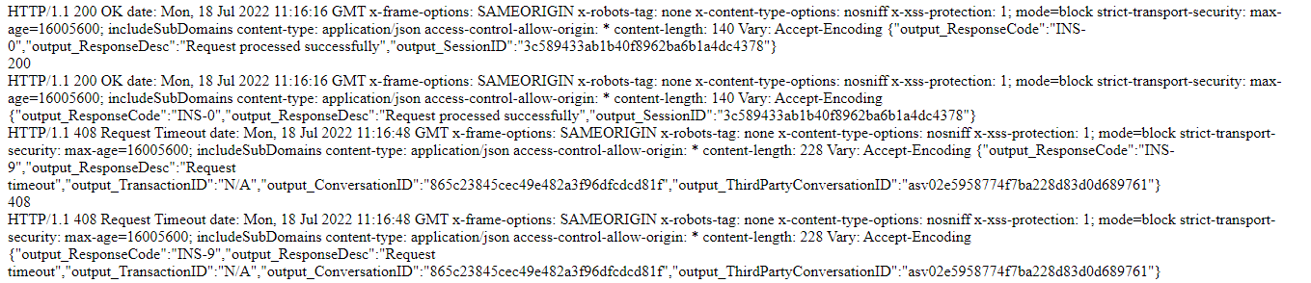

**USSD Push timeout 03**



Transaction failed [Invalid Pin] 04

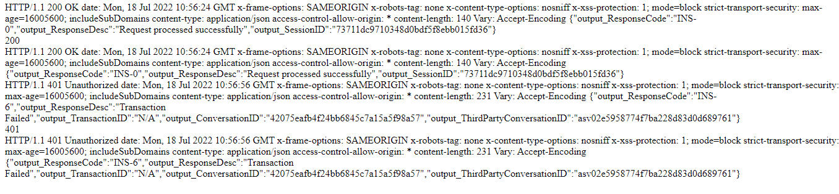

Internal Error

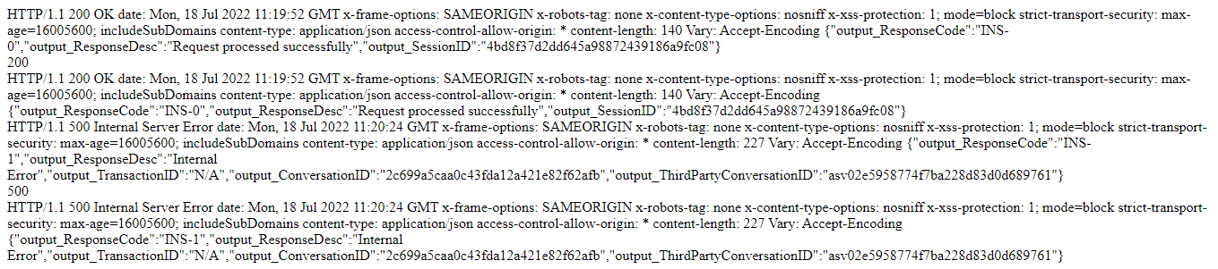

Transaction failed [Invalid Pin] 06



Invalid Amount 07

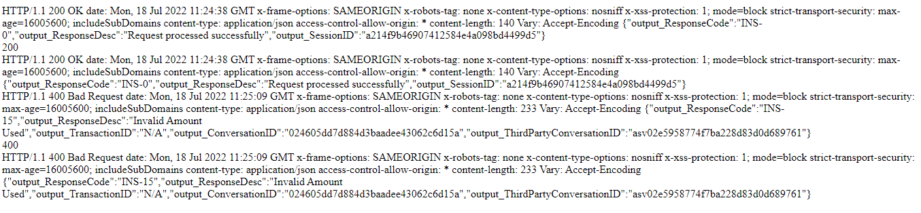

Insufficient Balance 08

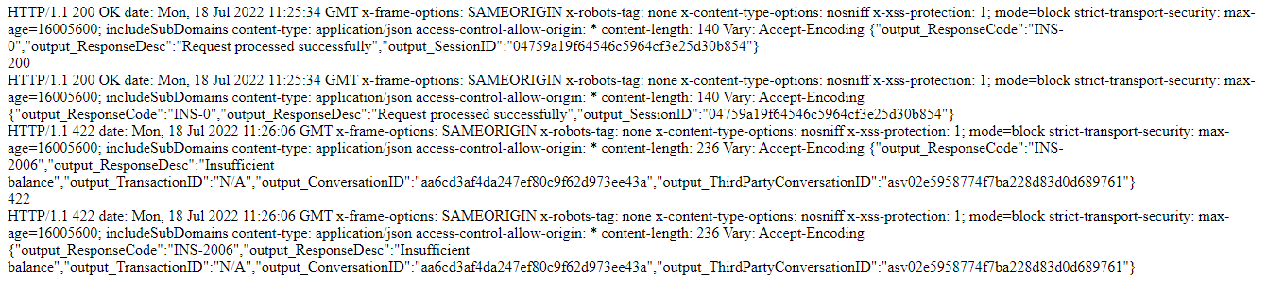

Service is not available 09

